Name : Sundara Moorthy
Reg No : 192324228
Course code : Cloud Computing And Big Data Analysis
Exp No : EXPERIMENT 17
Date : 23/12/2025

17. Changing Hardware Compatibility of a Virtual Machine
Aim
To change the hardware compatibility of an already created Virtual Machine using VMware Workstation.
Steps
- Power OFF the Virtual Machine.
- Select the VM → Click Manage → Change Hardware Compatibility
(or clone VM if the option is unavailable).
- Choose the desired VMware hardware version.
- Complete the wizard.
- Power ON the Virtual Machine.
- Verify updated hardware compatibility in VM settings.
Output
• Hardware compatibility successfully updated.
• Virtual Machine runs without errors.

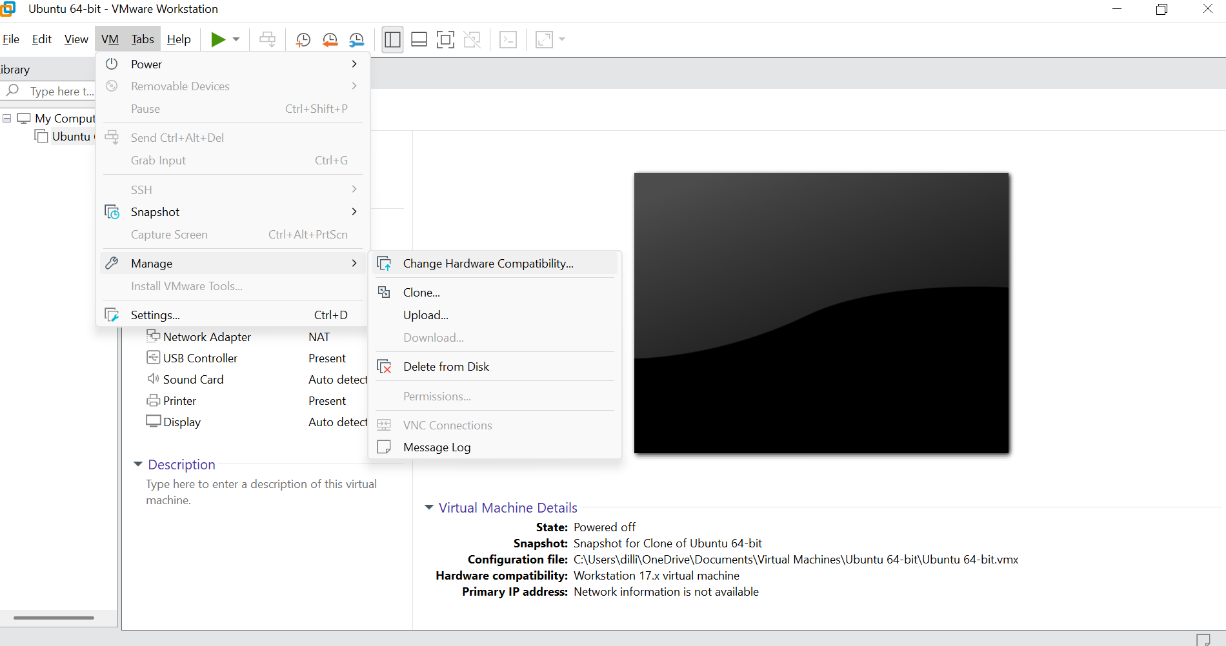
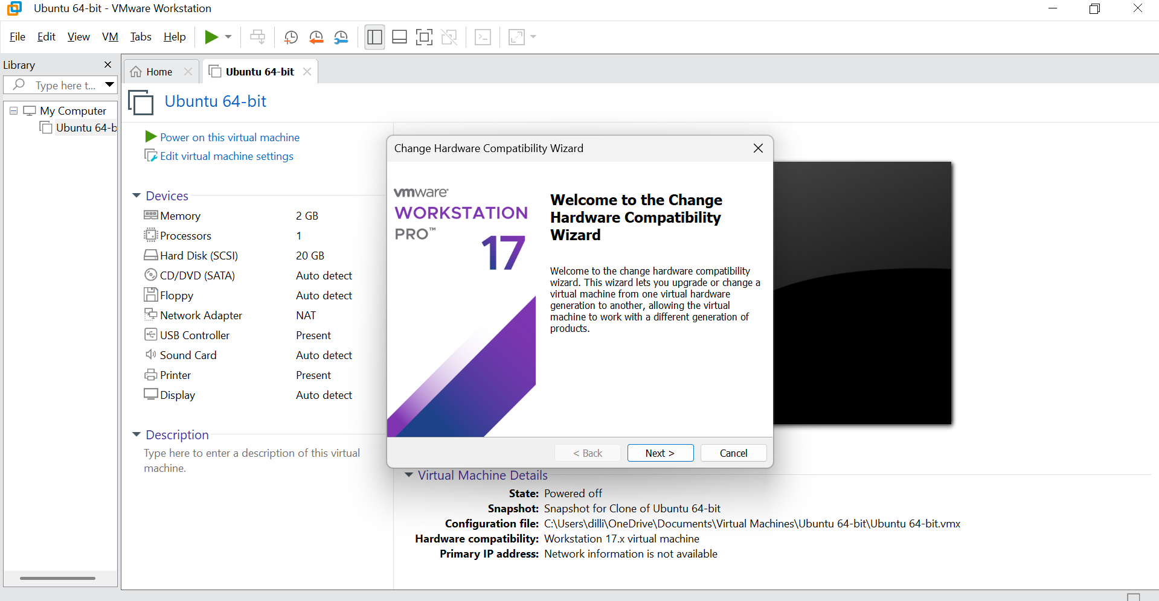
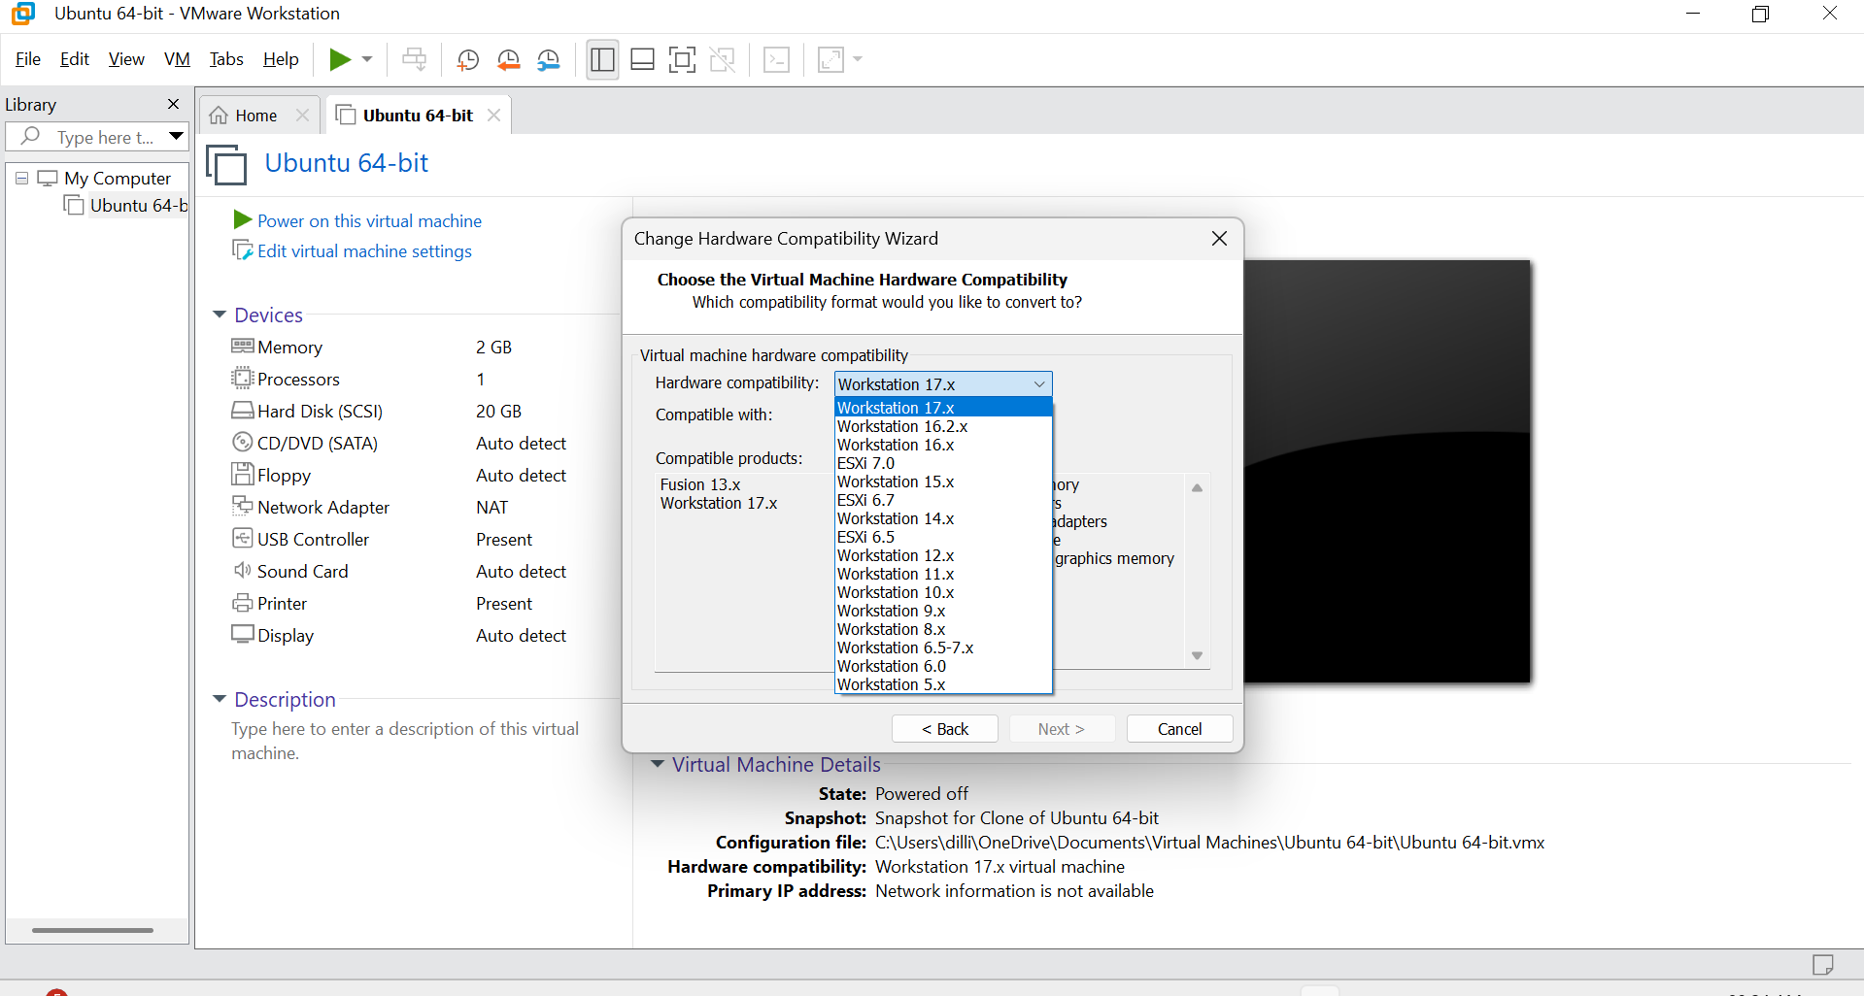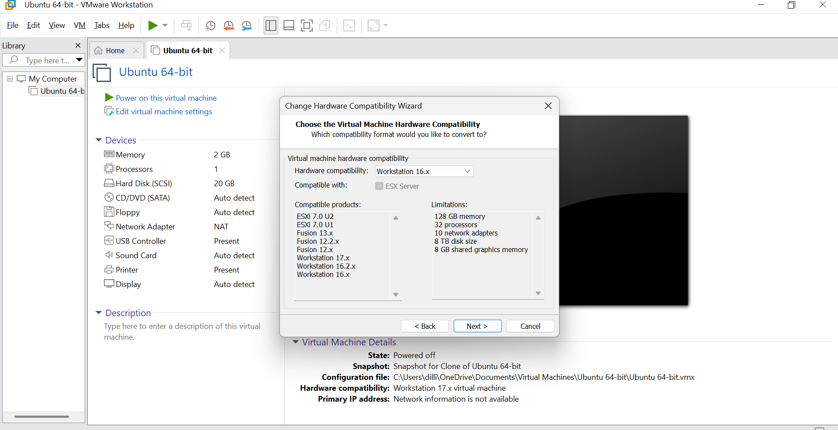

Result
Thus, the hardware compatibility of the Virtual Machine was successfully changed using VMware Workstation.

